**Use Process Advisor with Data**

In this exercise, you will create a process advisor from existing process data and review the analytics.

**Task 1: Create process advisor**

1. Navigate to [https://make.powerautomate.com](https://make.powerautomate.com/) and make sure you are in the dev environment you created.
2. Select **Process advisor** from the left-hand navigation pane and click **+ Start here**.

[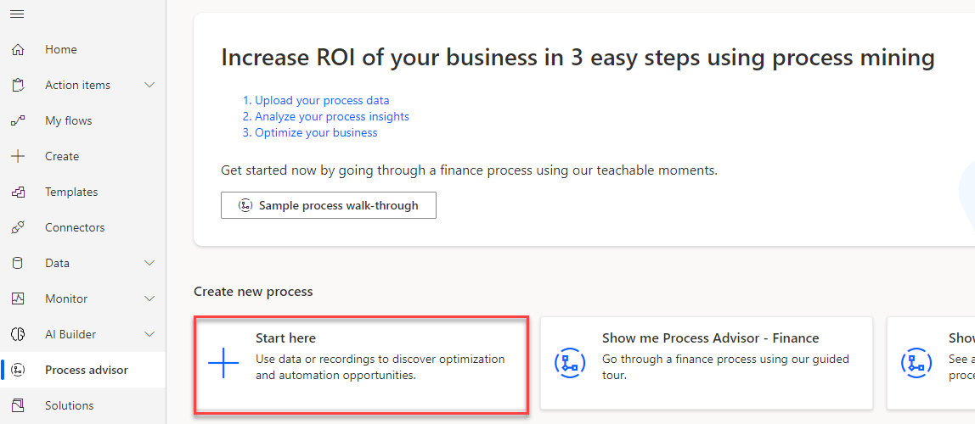](https://github.com/MicrosoftLearning/PL-500T00-Microsoft-Power-Automate-RPA-Developer/blob/master/Instructions/L01/media/image1.png)

1. Enter **Loan Funding - Data** for Process name, select **Data**, and click **Create**.

[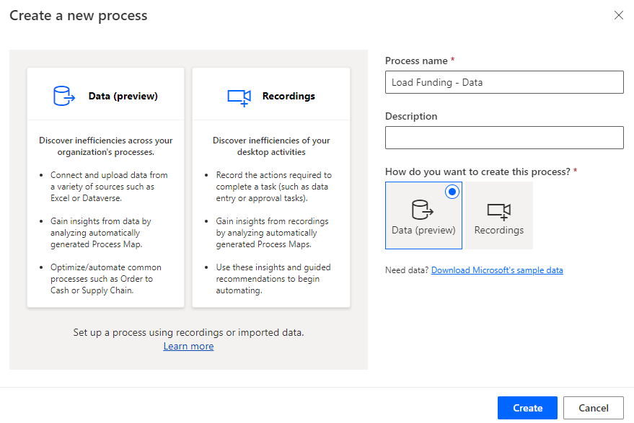](https://github.com/MicrosoftLearning/PL-500T00-Microsoft-Power-Automate-RPA-Developer/blob/master/Instructions/L01/media/image2.png)

1. Select **Excel workbook**.
2. Select **Upload file** and click **Browse**.

[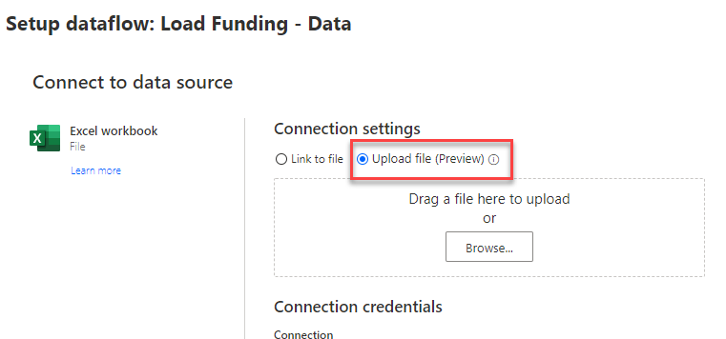](https://github.com/MicrosoftLearning/PL-500T00-Microsoft-Power-Automate-RPA-Developer/blob/master/Instructions/L01/media/image3.png)

1. Select the **ExistingProcessData.xlsx** file located in the lab resources folder and click **Open**.
2. Click **Sign in**.

[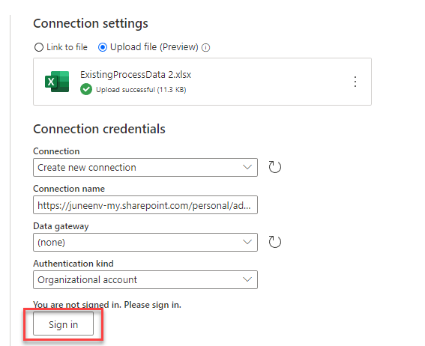](https://github.com/MicrosoftLearning/PL-500T00-Microsoft-Power-Automate-RPA-Developer/blob/master/Instructions/L01/media/image4.png)

Note: You may need to configure your pop-up blocker to allow this site to create pop-up windows.

1. Provide your credentials and sign in.
2. Click **Next**.

[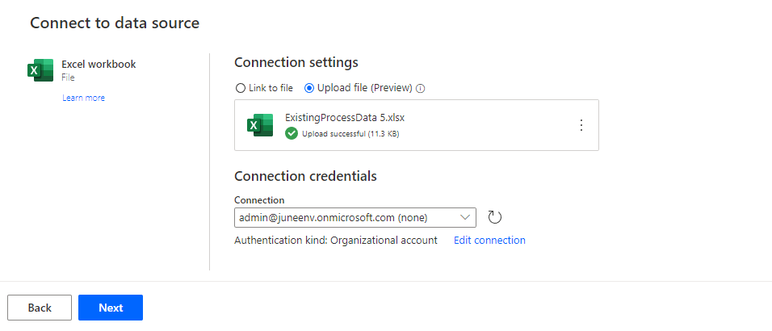](https://github.com/MicrosoftLearning/PL-500T00-Microsoft-Power-Automate-RPA-Developer/blob/master/Instructions/L01/media/image5.png)

1. Select **ConstructionFunding** for data and click **Next**.

[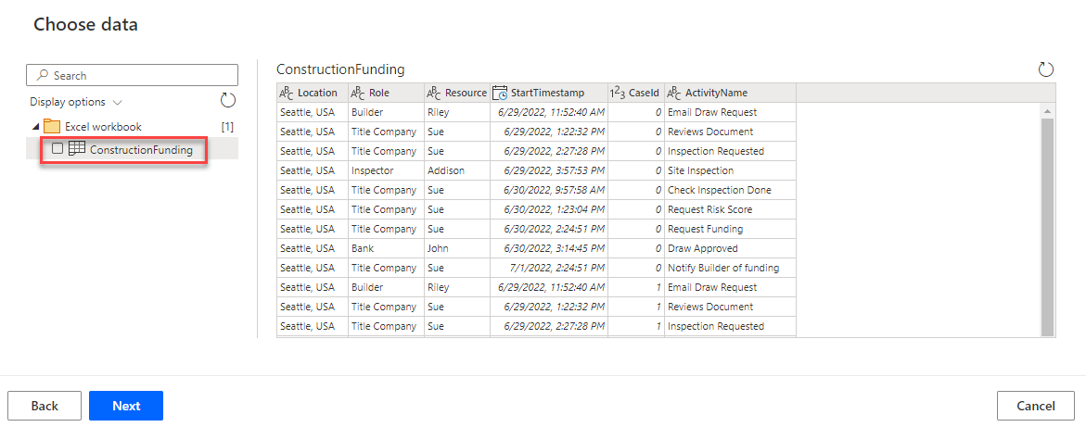](https://github.com/MicrosoftLearning/PL-500T00-Microsoft-Power-Automate-RPA-Developer/blob/master/Instructions/L01/media/image6.png)

1. Click **Save and analyze**.

[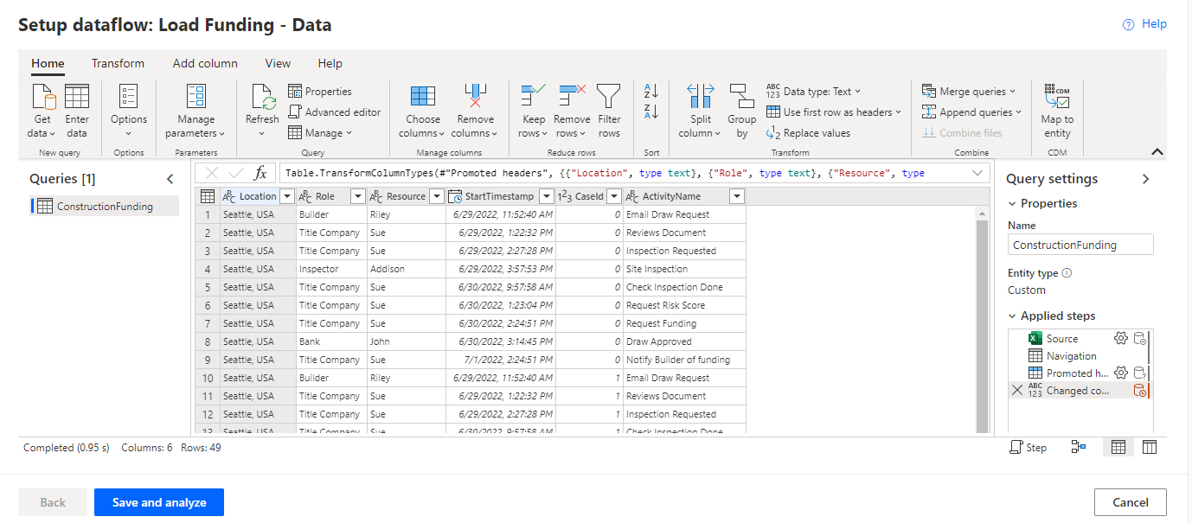](https://github.com/MicrosoftLearning/PL-500T00-Microsoft-Power-Automate-RPA-Developer/blob/master/Instructions/L01/media/image7.png)

1. Wait for the analyzing to complete.
2. Do not navigate away from this page.

**Task 2: Review analytics**

1. The produced process map should look like the image below.

[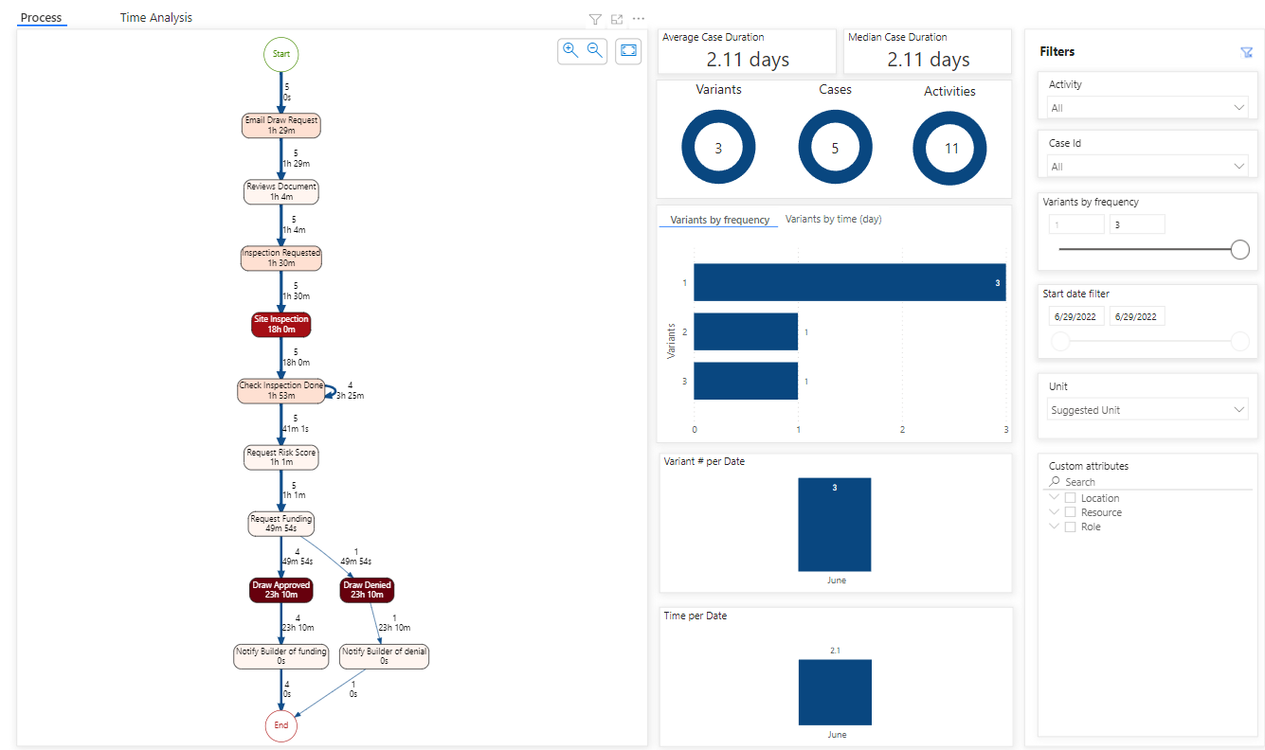](https://github.com/MicrosoftLearning/PL-500T00-Microsoft-Power-Automate-RPA-Developer/blob/master/Instructions/L01/media/image8.png)

1. Zoom in and go to the Request Funding activity. Notice there is a path or variant for approved draw and a different one for denied draw.

[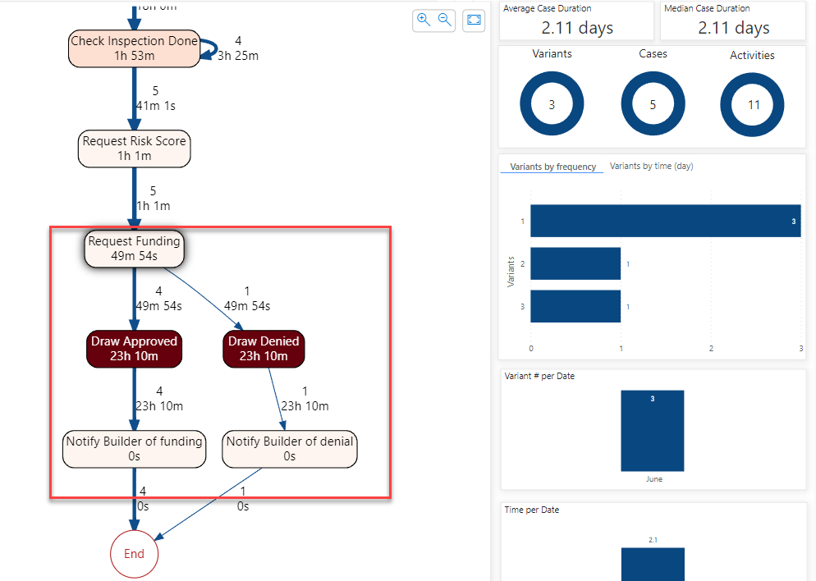](https://github.com/MicrosoftLearning/PL-500T00-Microsoft-Power-Automate-RPA-Developer/blob/master/Instructions/L01/media/image9.png)

1. Go to the Variants by frequency chart and select bar with the highest frequencies. This is the most common path the process takes; in our case this is the approved draw path.

[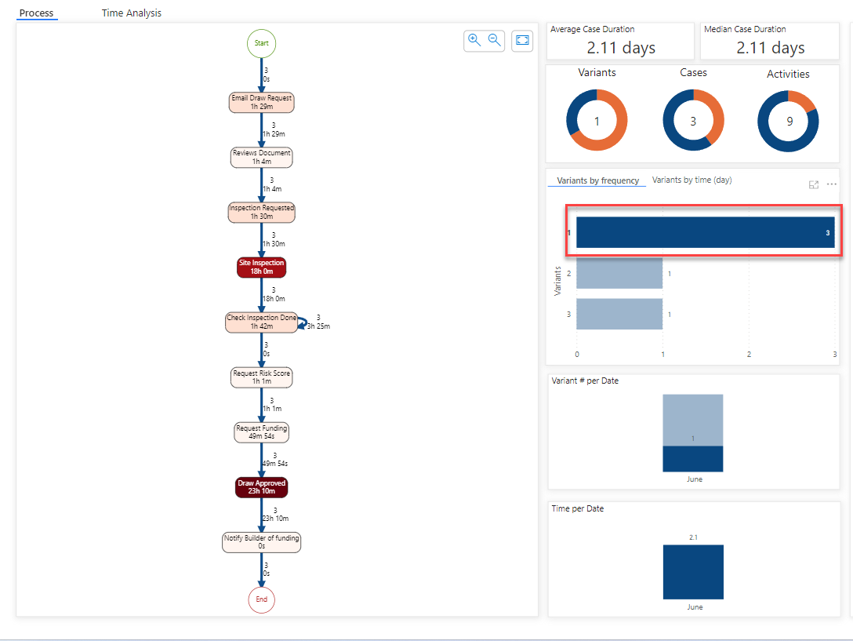](https://github.com/MicrosoftLearning/PL-500T00-Microsoft-Power-Automate-RPA-Developer/blob/master/Instructions/L01/media/image10.png)

1. Go to the Variants by frequency chart and select the second bar. This is the frequency for the approved draw path.

[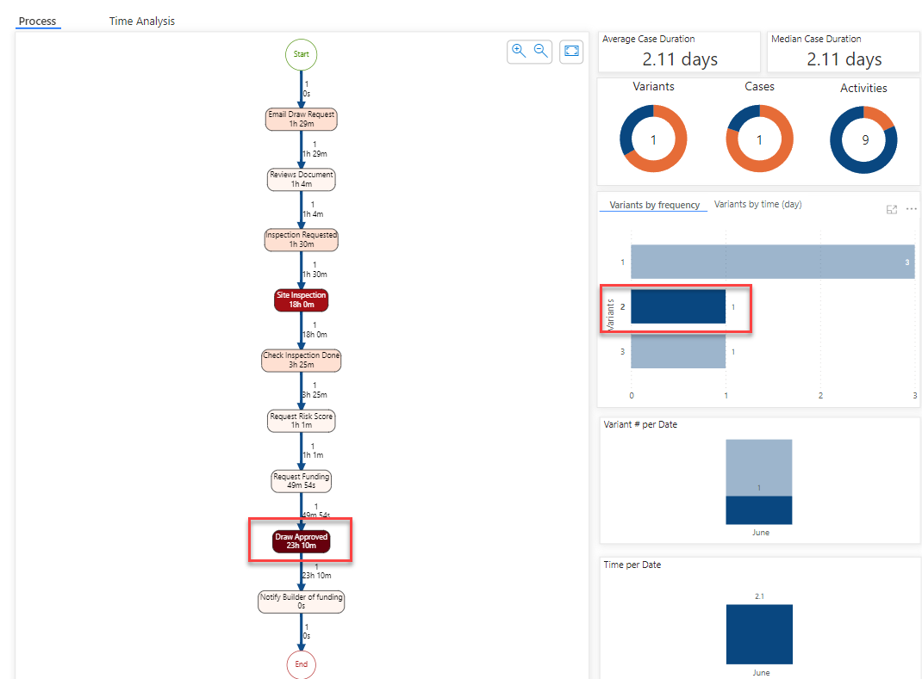](https://github.com/MicrosoftLearning/PL-500T00-Microsoft-Power-Automate-RPA-Developer/blob/master/Instructions/L01/media/image11.png)

1. Select the last bar. This is the frequency for the denied draw.

[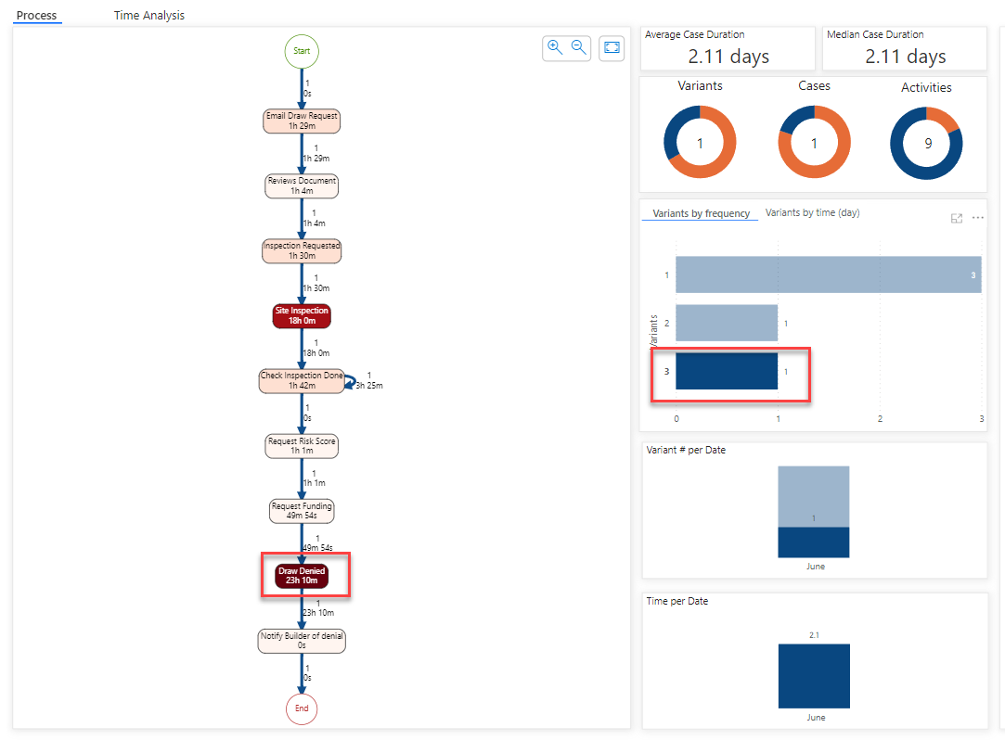](https://github.com/MicrosoftLearning/PL-500T00-Microsoft-Power-Automate-RPA-Developer/blob/master/Instructions/L01/media/image12.png)

1. Select the Time Analysis tab. This tab shows information includes how much time is spent on each activity, on each variant, and more.

[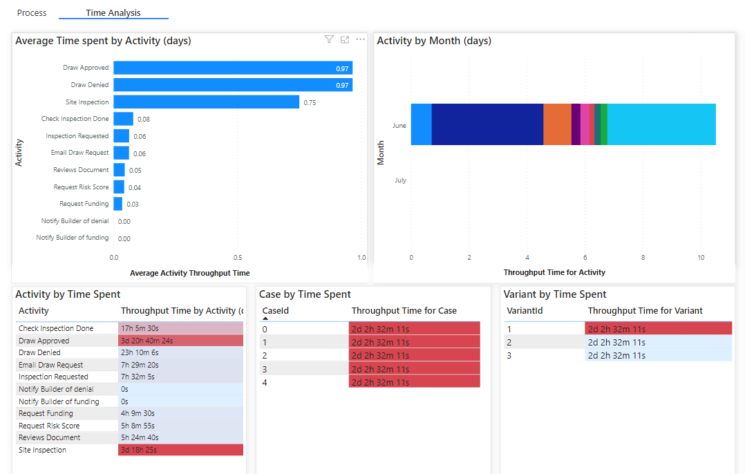](https://github.com/MicrosoftLearning/PL-500T00-Microsoft-Power-Automate-RPA-Developer/blob/master/Instructions/L01/media/image13.png)

1. The charts allow drilling down on a specific data point and filtering.